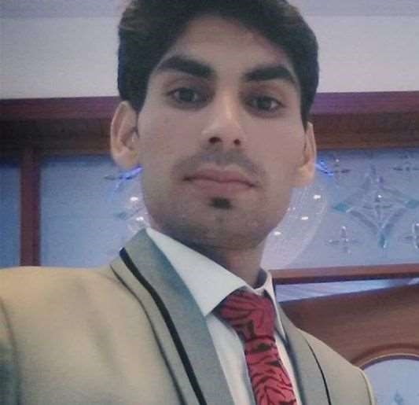Muhammad Waqar| Software Engineer

Location: Lahore

Contact No: 03046208020

Email: waqarahmadddd@gmail.com

# Professional Profile

• Designing and Developing Android applications.

• Planning and devising on-page optimization strategies as per Native App requirements

• Can create robust user-friendly front-end screens.

• Create INSERT/SELECT/UPDATE statements to be able to successfully manipulate database data.

• Propose and introduce technical solutions in the area of responsibilities, perform work breakdown, estimates

• Well communication skills

# Core Skills

|  |  |
| --- | --- |
| * Android React Native * React Native Apps Design/UI * Firebase ads Implementation | * Firebase Push Notification * React native JS Lib * Play Console Interaction |

# Experience

• Shopping Mobile Application

• Help Mobile Application

• Apex Mobile Application

• Fazal Son`s Mobile Application

Experience

Dec2020 – Mar 2021 Service Provider Pk Punjab Society Lahore cantt

Position Android React Native Developer

**Key Responsibilities**

* Android Application Developing
* Application UI Design
* API integrated with UI Design

# FYP

Women Safety Mobile Application:

* On emergency button press sends
* Location, and Bio data of victim via SMS
* Application send location and Bio also Police Station

Education & Qualification

|  |  |  |  |
| --- | --- | --- | --- |
| **Degrees**    BS Software Engineering from Lahore Garrison  University    Intermediate from KIPS College Garden Town Lahore    Matric from Government Islamia High School Baddomalhi District Narowal | **Division or CGPA** | | **Passing Year**    2020      2016      2013 |
|  | 2.79      745/1100    832/1050 |

# Hobbies

* To Learn Programming languages
* Software Development
* Playing Cricket and Football